Business Policy
Policy Level | One
Policy Category | Business
Policy Authority | Board
Lead Committee | Senior Leadership Team
Lead Director | Phillipa Spicer
Approved Date | 27/07/2026
Review Date | 31/07/2028

Our policy is to provide a fair, ethical and legal framework for the delivery of our business. We will ensure our assets and resources are used appropriately and efficiently for their designated purpose. We will work to balance the needs of stakeholders, beneficiaries, and staff.

We will comply with relevant legislation, in particular the Charities Act 2022, Regulator of Social Housing Regulatory Standards, the Fundraising Regulator and the Companies Act 2006.

To this end, we will:
- Ensure we have a suitably qualified and experienced board of trustees.
- Ensure we have a suitably qualified and experienced senior staff team.
- Actively ensure the safety of our customers’ data, our assets and other resources.
- Identify, assess and mitigate against key business risks
- Actively assess the ethical nature of all areas of our business and benchmark these against the YMCA Way.
- Seek to engage with stakeholders, beneficiaries and staff, utilising suitable tools.
The governance structure of YMCA Fairthorne Group is depicted in the diagram below. This is regularly reviewed to ensure the structure meets the needs of the organisation.

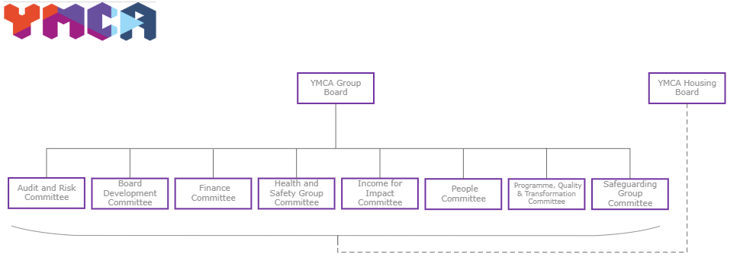

This policy is supported by the following policies and guidance:

- Anti-fraud and Corruption Policy Level 2
- Company Vehicle Policy Level 2
- Complaints Policy Level 2
- Data Protection & Information Security Policy Level 2
- Financial Controls Policy Level 2
- Fundraising Policies Level 1 & 2
- Inclement Weather and Travel Disruption Policy & Procedure Level 2
- Risk Management Policy Statement & Risk Management Policy and Procedures

